Food Delivery Analytics Report

1. Introduction
This report presents a comprehensive analysis of a food delivery dataset, focusing on operational performance, financial outcomes, driver efficiency, and customer behaviour. Using Power BI, the project transforms raw data into actionable insights to support decision-making.

2. Objectives
This project aims to:
- Analyse financial performance by examining revenue streams, discounts, and refunds to identify areas of revenue leakage
- Evaluate delivery performance by analysing key time-based metrics
- Assess driver efficiency and workload distribution to uncover performance gaps and opportunities for optimization
- Understand customer behaviour patterns, including ordering trends, preferences (ASAP vs scheduled), and spending habits
- Identify peak demand periods to support better resource allocation and operational planning
- Provide data-driven recommendations to enhance delivery speed, improve customer satisfaction, and increase profitability

3. Data Cleaning & Preparation

Before analysis, the dataset underwent several transformations and cleaning steps to ensure accuracy and usability.

Data Cleaning Steps:

- Removed empty/null values across columns to improve data quality
- Checked for and handled inconsistent or missing records
- Standardised column formats for consistency

Data Type Transformation:

- Converted date columns to Date format
- Converted time-related columns (initially in text) into Time format
- Converted ID columns(Customer ID, Driver ID, Restaurants ID) to text format
- Ensured numerical columns (fees, tips, subtotal, refunds) were correctly set as numeric data types

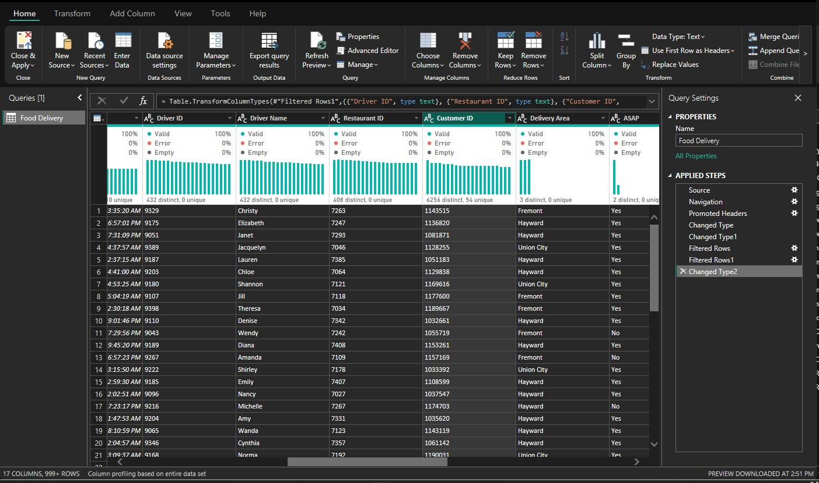

Date Table and Calculated Columns Created:

To enable deeper analysis, several new columns were created:
- Date table
- Hour of Order → extracted from order time
- Order → Restaurant Time
- Restaurant → Driver Time
- Driver → Customer Time
- Total Delivery Time

These columns helped break down the delivery lifecycle into measurable stages.
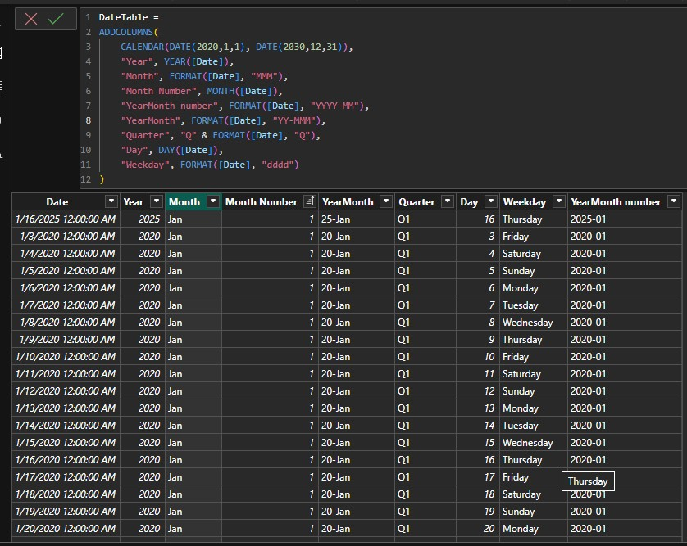

DAX Measures Developed:

Key performance indicators were created using DAX, including:
- Total Orders
- Total Revenue
- Average Delivery Time
- On-Time Delivery Rate
- Refund Rate
- Average Tip
- Revenue components (fees, discounts, refunds)

Outcome:
These transformations ensured:
- Accurate time-based analysis
- Reliable KPI calculations
- Structured data for effective visualization

4. Insights and findings

1. Financial Performance Analysis

Key Metrics:
- Total Revenue: 6.06M
- Refund Rate: 0.77%

Key Insights:

Revenue Distribution by Time
- Revenue peaks in the early hours, then declines sharply before stabilising later in the day.
- This aligns with order volume trends, confirming demand-driven revenue patterns.
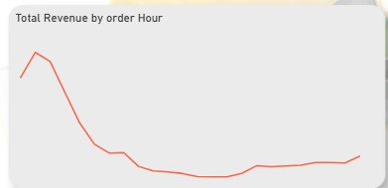

Revenue by Delivery Area
- Union City (2.03M) generates the highest revenue
- Followed closely by Hayward (2.02M) and Fremont (2.01M)

Revenue distribution is relatively balanced, indicating no extreme dependency on a single location.

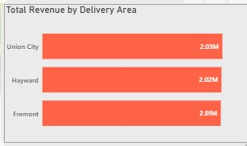

Delivery Time vs Revenue
- Areas with longer delivery times (e.g., Union City ~134 mins) still generate high revenue.

Insight:
High-demand areas are generating strong revenue despite slower delivery, suggesting potential strain on operations.

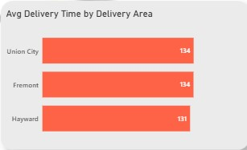

2. Delivery & Operations Analysis

Key Metrics:
- Total Orders: 54K
- Average Delivery Time: 133.27 minutes
- On-Time Delivery Rate: 4.62%

Key Insights:
Critical Performance Issue
- The on-time delivery rate is extremely low (4.62%)
- The average delivery time (133 minutes) is significantly high

Insight:
The platform is experiencing severe delivery delays, which likely contribute to refunds and customer dissatisfaction.

Order Trends
- Orders fluctuate significantly over time with frequent spikes, indicating inconsistent demand patterns.

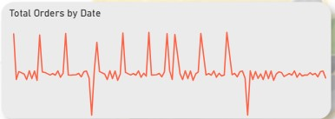
Orders by Hour
- Peak orders occur during early hours, then drop drastically before gradually increasing again later.

Insight:
Demand is time-sensitive, requiring dynamic resource allocation.

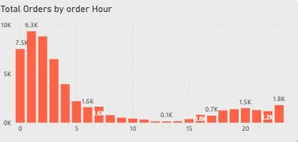

Area Performance
- Fremont has the highest order volume
- However, delivery times remain high across all areas (~131–134 mins)

Insight:
High demand is not matched with sufficient delivery capacity.

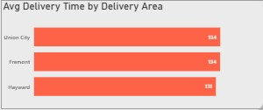

Delivery Stage Breakdown

The largest portion of the delay comes from:
- Restaurant → Driver time
- Driver → Customer time

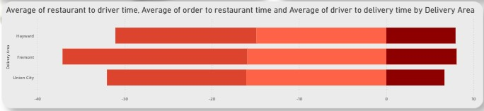
Insight:
Bottlenecks are primarily in driver allocation and delivery execution, not order placement.

3. Driver Performance Analysis

Key Metrics:
- Total Drivers: 432

Key Insights:

Driver Efficiency Variability
Significant differences in average delivery time across drivers:
- Fastest ~152 mins
- Slowest ~208 mins

Indicates inconsistent driver performance

Workload Distribution
Top drivers handle:
- Erin (190 orders)
- Bailey (189 orders)

Workload is not evenly distributed.

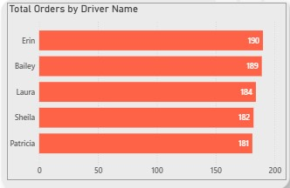

On-Time Delivery (Driver Level)
- Individual on-time rates remain below 1%

Insight:
The issue is systemic, not just individual driver performance.

4. Customer Behaviour Analysis

Key Metrics:
- Total Customers: 6.25K

Key Insights:

ASAP vs Scheduled Orders
- ~80% of orders are ASAP
- Only ~20% are scheduled

Insight:
Customers strongly prefer immediate delivery, increasing pressure on operations.
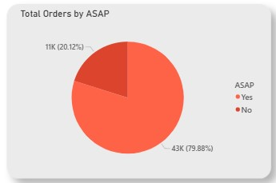

Tip vs Delivery Time (Scatter Plot)
- Higher tips are associated with shorter delivery times
- Longer delivery times tend to result in lower tips

Insight:
Delivery speed directly impacts customer satisfaction and tipping behaviour.
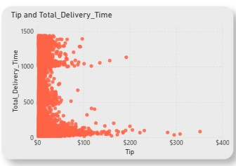

Order Heatmap (Day vs Hour)
- Peak activity observed:
- Morning to early afternoon hours
- Consistent demand across weekdays

Insight:
Demand is predictable and time-based, allowing for better planning.
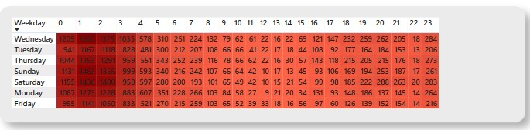

5. Key Challenges Identified
- Extremely low on-time delivery rate (4.62%)
- High average delivery time (133 mins)
- Driver allocation inefficiencies
- Uneven workload distribution
- Revenue at risk due to operational delays

5. Dashboard Overview
https://app.powerbi.com/view?r=eyJrIjoiZjBlODMzNTMtNTNhNy00MWZhLTlmY2QtYmNiZDI3MDJjMmU3IiwidCI6Ijg1MGM1NTQ5LTE2ZjktNDJjOS05NWI0LTM4MzE3ZjA0OWZjMCJ9

6. Recommendations

Operational Optimization
- Implement real-time driver allocation systems
- Increase driver availability during peak hours
- Optimise delivery routing using location intelligence

Driver Management
- Introduce performance-based incentives
- Balance workload across drivers
- Provide training for underperforming drivers

Financial Strategy
- Reduce excessive delays to lower refund rates
- Align pricing strategies with delivery performance

Customer Experience
- Improve delivery speed to increase tips and retention
- Introduce incentives for scheduled orders to reduce pressure

7. Limitations of the Study

A key limitation of this analysis was the presence of incomplete and missing data within the dataset. Approximately 25% of the records contained missing or inconsistent values across critical fields such as time-related variables.

To ensure the accuracy and reliability of the analysis, these records were removed during the data cleaning process. While this improved data quality and prevented misleading results, it also reduced dataset size, which may limit the overall representativeness of the findings.

As a result:
- Certain patterns or behaviours may be underrepresented
- Insights may be slightly biased toward complete records
- The analysis may not fully capture all operational scenarios

8. Conclusion

The analysis clearly shows that while the platform performs well financially, operational inefficiencies—especially in delivery execution—are limiting overall performance.

Improving delivery speed, optimizing driver allocation, and aligning operations with customer demand patterns will significantly enhance:
- Customer satisfaction
- Revenue retention
- Operational efficiency

